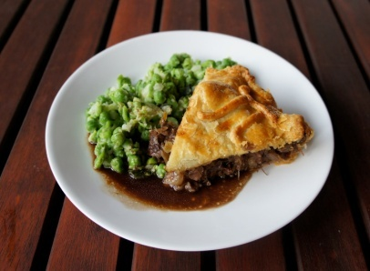
Gainsborough & District Conservatives
‘Pie & Peas’ supper
BOOKING FORM

- Please reserve . . . . . . . place(s)for the Supper on 21st October 2022

- I am unable to attend, but wish to be informed of future events

Name: . . . . . . . . . . . . . . . . . . . . . . . . . . . . . . . . . . . . . . . . . . . . . . . . . . . . . .
Address: . . . . . . . . . . . . . . . . . . . . . . . . . . . . . . . . . . . . . . . . . . . . . . . . . . . .
. . . . . . . . . . . . . . . . . . . . . . . . . . . . . . . . . . . . . . . . . . . . . . . . . . . . . . . . . . . .
Telephone: . . . . . . . . . . . . . . . . . . . . . . . . . . . . . . . . . . . . . . . . . . . . . . . . . .
Email: . . . . . . . . . . . . . . . . . . . . . . . . . . . . . . . . . . . . . . . . . . . . . . . . . . . . . .
Tickets £13 per person – covers main meal. Dessert & drinks extra

R.S.V.P by Monday 17th October by returning the completed booking form and your payment to the Branch Secretary: Mrs Sheila Bibb, 6 The Pines, Gainsborough, DN21 1PW; by phoning Sheila on either 01427 614360 or 07881497459; or alternatively email to sheilabibb@yahoo.com
Payment details:
BACS:
Sort Code: 52-41-46
Account number: 05282985
Account name: Gainsborough Conservative Association Gainsborough Branch
Reference: PIEPEA211022

Cheques should be made payable to
‘Gainsborough Conservative Association Gainsborough Branch’.

Please let us know in advance if you have any special dietary requirements
e.g vegetarian, gluten free

HOW WE USE YOUR INFORMATION The information you provide will be used for these purposes only and will be used only by the Conservative Party; including its candidates, representatives and associations. We will not give information to anyone else and it will be easy to withdraw your consent at any time.
Printed and Promoted by Sheila Bibb on behalf of Gainsborough & District Conservative Branch 6 The Pines, Gainsborough, DN21 1PW

